Conice nedegenerate:  
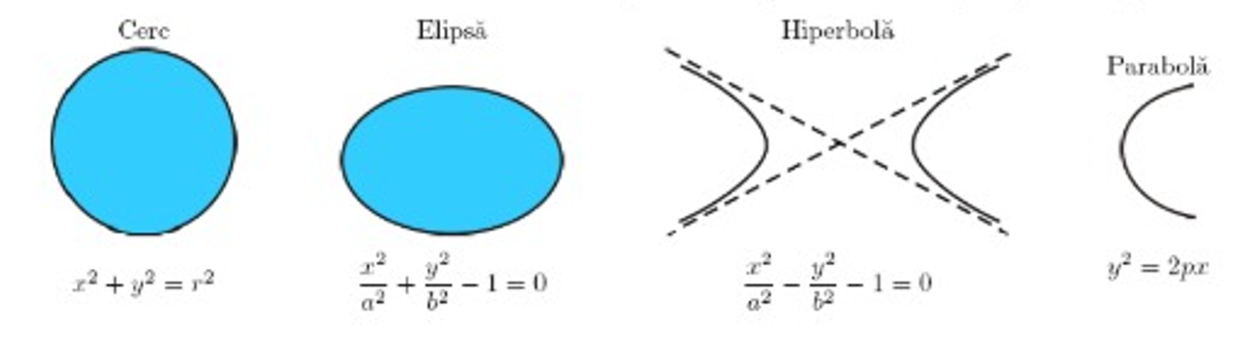

Conice degenerate:

Elipsoidul:

Hiperboloidul cu o pânză:

Hiperboloidul cu două pânze:

Paraboloidul eliptic:

Paraboloidul hiperbolic:

Cilindrul eliptic:

Cilindrul hiperbolic:

Cilindrul parabolic:

Conul pătratic:

